Sample Output :

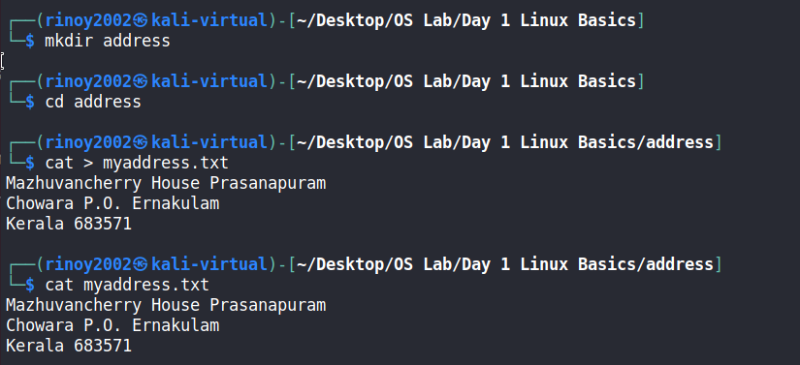

Sample Output :

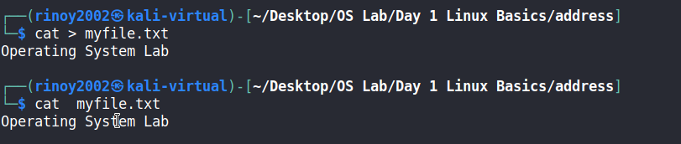

Sample Output :

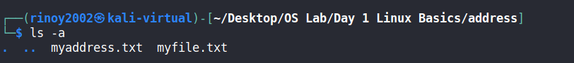

Sample Output :

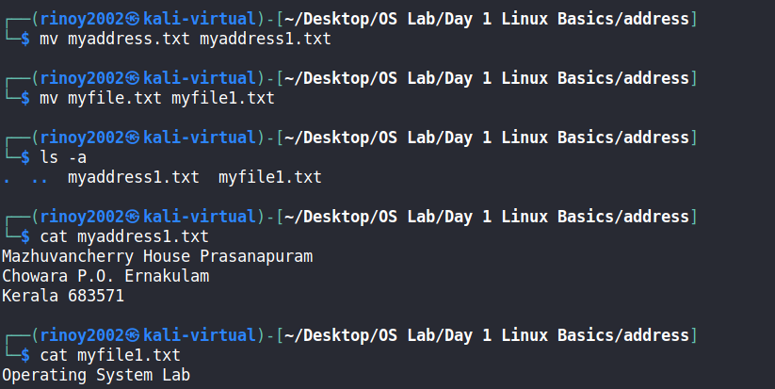

Sample Output :

